Big Data Analytics of Chicago Crime Trends Using Hadoop and Hive

Authors: Isabella Jimenez, Jasmine Carvalho, Karla Salazar, Sherman Liang,
Department of Information Systems, California State University, Los Angeles
CIS 4560-02 Introduction to Big Data
ijimen48@calstatela.edu, jcarval2@calstatela.edu, ksalaz63@calstatela.edu, sliang30@calstatela.edu,

Abstract: This project analyzes the Chicago Crimes 2001–Present (2.2GB) dataset from the City of Chicago Data Portal [1] to identify trends in criminal activity across time and location. The dataset comprises more than two decades of reported crime incidents in Chicago, spanning from 2001 to the present (excluding the most recent seven days). It contains key information such as date, block (instead of address), district, community area, latitude, longitude, and crime type.
Using Hadoop and Hive, the analysis collects crime data to identify changes and patterns in crime statistics, including the total number of crimes by year, the most common types of crimes, and the frequency of crimes by district, day of the week, and time of day. Simple visualizations from Power BI, such as bar charts and line graphs, are used to show these trends. This project aims to identify when and where crimes occur most frequently, highlight high-crime areas, and provide insights that can support public safety awareness and data-driven decision-making.
1. Introduction
The project uses Hadoop and Hive to analyze Chicago urban crime data. This data analysis aims to identify patterns that can improve public safety and resource allocation in the city of Chicago. We chose the Chicago crime dataset because Chicago is a large metropolitan city, much like Los Angeles, where this research is compiled and presented. Chicago has one of the most detailed public crime databases, which would be the most insightful for data analysis on urban crime.
The dataset details information on dates, crime types, and geographical markers (blocks, districts, community areas, longitude, and latitude). Using Hadoop and Hive, the project collects and organizes data to identify the most frequent crime types, their locations of occurrence, and corresponding times of occurrence. With Excel, visualizations were created to identify high-crime districts and generate meaningful insights for raising safety awareness and informing Chicago’s leaders to make better decisions.
2. Related Work
A study by Feng et al. [2] analyzes crime records from various cities, including San Francisco, Chicago, and Philadelphia, using both statistical visualization and time-series forecasting methods. Their research uses the Prophet model, described as “a procedure for forecasting time series data based on an additive model where non-linear trends are fit with yearly, weekly, and/or daily seasonality, plus holiday effects” [2. p. 7]. This model is suitable when seasonal variations influence the data. They also implemented a Long Short-Term Memory (LSTM) model, which is a “powerful type of recurrent neural network (RNN), capable of learning long-term dependencies” [2. p. 8]. This model performs best for correlated time-series data, such as crime events.
A study by Chen, Bowers, and Cheng [3] analyzed the impact of dynamic activity on property crimes across London neighborhoods from 2020 to 2021, during the COVID-19 pandemic. By analyzing GPS data from nearly two million mobile phone users, they were able to measure the number of people present in a specific area at different times of day, demonstrating the presence of human activity. This study also combined GPS data with socioeconomic data and information about places that are likely to attract crime by using and training the Least Absolute Shrinkage and Selection Operator (LASSO) model, which can “conduct the empirical analysis due to the models’ superiority in regression tasks” [3, p. 8]. They also trained another model, called geographically weighted regression (GWR), to reveal the association between distinct variables and specific types of crimes. The results showed that crimes such as theft, shoplifting, and robbery were correlated with busy daytime periods, specifically midday on weekdays. Property crimes, such as bike theft or burglary, were not frequent occurrences. The study concluded that population movement indeed had an impact on shaping crime patterns during different phases of the pandemic lockdown.
A study by Mahimkar [4] demonstrates how to predict crime locations by combining big data analytics with the MapReduce framework. MapReduce was utilized in this study to enhance the precision of crime location predictions, thereby revealing distinct crime patterns and trends that can inform law enforcement and enable them to allocate resources more effectively. To conclude, Mahimkar collected data from various sources, including police reports, public crime datasets, and social media, and then processed them using distributed computing to facilitate real-time analysis.
While the three studies focused on different approaches for crime analysis, prediction, and visualization, our Chicago Crime Data Analysis using Hadoop and Hive stands out for its cloud-based Big Data, which enables us to have access to large-scale data processing, real-time analytics, and data management across different cities, specifically in our case, Chicago. While the others focused on [2], which analyzed trends in various cities using models such as Prophet and LSTM. [3] investigated how human mobility affects property crimes in different areas of London using LASSO and GWR, while [4] applied MapReduce to predict crime locations from various data sources. In comparison, our work utilizes Hadoop and Hive to process large-scale crime datasets from Chicago, enabling us to handle the data efficiently and continuously analyze it through Hive on the cloud. This process makes it more efficient if we want to view the data being analyzed and visualized in real-time.
3. Specifications
The dataset comprises the reported crime incidents from the City of Chicago’s open data portal [1]. Since the Chicago dataset is publicly accessible and continuously updated by the Chicago Police Department, it was directly obtained for this project. The dataset contains all recorded crimes from 2001 to the present, excluding the most recent seven days. Although the dataset is large in size (~2.2 GB), we assume the same data processes can be applied to even larger datasets (100 GB+). Table 1 shows the dataset and its basic specifications.
Table 1: Data Specification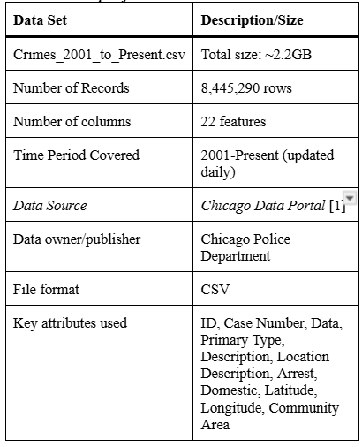. The table below outlines the specifications for the Hadoop environment used, as well as the system configuration details for our analysis.
Table 2: System and Hadoop Cluster Specification
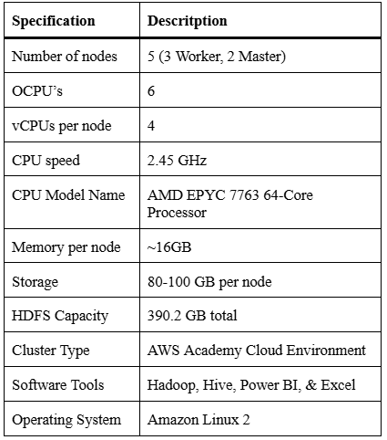

4. Implementation Flowchart
The project’s implementation is structured as a six-stage analysis pipeline. The workflow begins with Raw Data Acquisition, which involves securing the dataset and transferring it to the Hadoop server. The data is then immediately moved into the Hadoop Distributed File System (HDFS), making it accessible to the cluster’s services. This is followed by creating external tables in HiveQL, which uses the Beeline client to define the data’s schema, including initial raw and clean table structures, to map the CSV data in HDFS. The most crucial transformation occurs when creating a summary table for analysis, where HiveQL is used to build a final, clean table by correcting and formatting vital data fields (such as converting dates into accurate timestamps) and removing any incomplete records. Then, we use queries to write the summarized data into an HDFS directory, and then retrieve those files to the Local directory. Finally, the exported CSV files are imported into Excel and Power BI to generate geo-spatial maps and analytical charts,
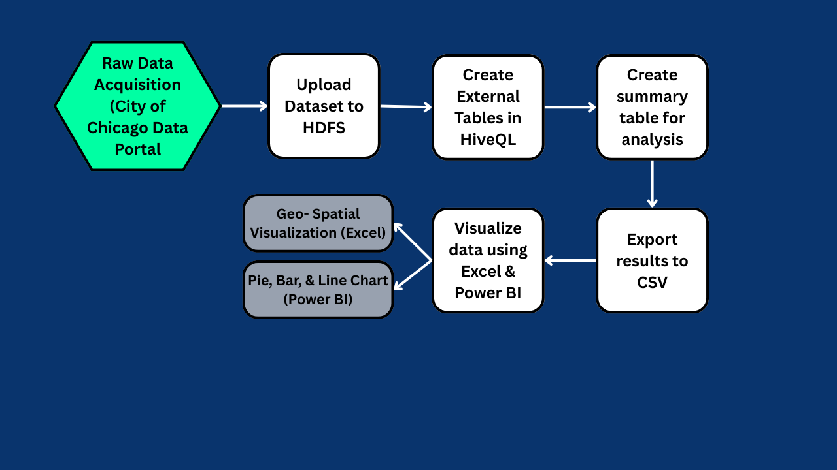
Figure 1- Implementation Flowchart
5. Data Cleaning
The data cleaning and refinement phase was a crucial part of preparing the large, raw Chicago Crime dataset for analysis. Instead of manually splitting the file, all cleaning was performed within HiveQL, transforming the initial data into a single reliable chicago_final table. This process began with the Chicago_raw table, which served as the initial, unaltered ingestion point for the complete dataset. Key cleaning operations, such as null value removal and date standardization, were then performed and stored in the intermediate chicago_cleaned table. Finally, the Chicago_final table was generated as the definitive source for analysis, selecting only the specific, cleaned columns required for our visualizations (e.g., Year, Hour, District, Longitude/Latitude). After the necessary standardization, the dataset was then segmented to create multiple smaller, specialized files (Table 3). Each had its purpose by aggregating data (such as counting crimes by district) and selecting only the columns necessary for particular visualizations. This method ensured that the final outputs (the exported CSVs) were manageable, precise, and ready for import into Excel and Power BI for visualization.
Table 3: Data Transformation and Output Files
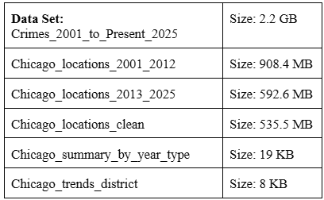
6. Analysis and Visualization
Following the data cleaning and refinement phase, the smaller Chicago Crime dataset files were used to conduct a comprehensive, multifactorial analysis of criminal activity across Chicago. This section serves two primary functions: first, to present core findings through data visualization using Excel and Power BI, mapping the spatial and temporal distribution of crime; and second, to provide a detailed breakdown of crime frequency, trends, and geographic concentration by police district.

6.1 Exploratory Data Visualization (Excel/Power BI)
6.1.1 Spatial Analysis of Crime Concentration by District (2010-2012)
Geographical visualizations were created to provide a spatial understanding of crime intensity, which is critical for resource allocation. The Map of Crime Frequency by District (2010-2012) (Figure 2) utilized location coordinates and crime counts to illustrate the spatial distribution of crime frequency across Chicago districts. The data reveal a heavy concentration of criminal activity in the South and West Side districts, specifically in Districts 7, 8, 9, 10, 11, 15, and 25.
There is moderate activity in the Downtown and Near North districts, specifically in districts 1 and 18. The lowest activity is concentrated in the North and Northwest districts, specifically in areas 16, 17, 18, 20, and 24, indicating non-violent incidents and overall lower crime rates.

Figure 2- Map of Crime Frequency by District (2010-2012)
When looking at the Map of Crime Frequency by District (2021-2025) (Figure 3), we can see that the crime frequency is still heavily concentrated in the South and West Side districts (7, 8, 9, 10, 11, 15, and 25), with District 11 and & showing the most significant and most persistent spikes. Additionally, there is an increase in activity in the Downtown and Near North districts (1, 12, and 18) compared to earlier years. Notably, some changes in the North and Northwest districts (16, 17, and 18) led to the emergence of new crimes, creating moderate hotspots.

Figure 3- Map of Crime Frequency by District (2021-2025)
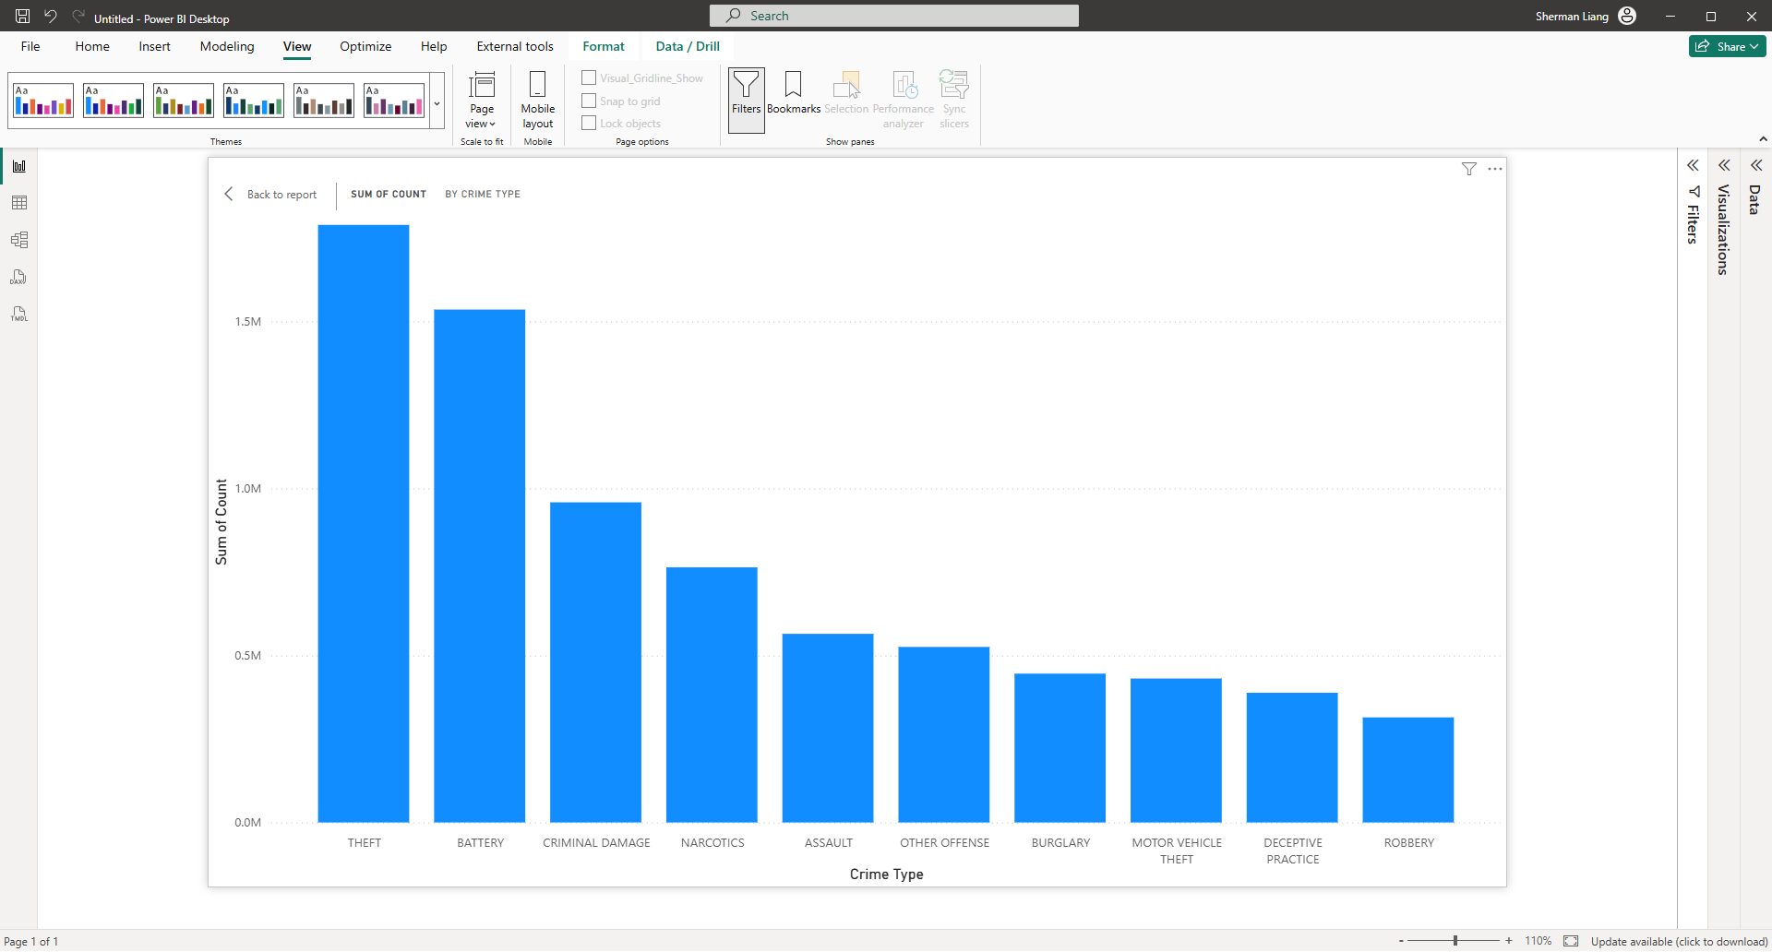
Figure 4- Top 10 Crime Types in Chicago (2001-2025)
The stacked column chart above displays the total number of each of the top ten crime types in Chicago from 2001 to 2025 (Figure 4). Theft (21.2%) and battery (18.2%) make up the two largest crime types in Chicago. The next largest categories are criminal damage (11.4%), narcotics (9.1%), and assault (6.7%) (Figure 5). All of the top crime types represent the most common and rampant crimes in Chicago over the past two decades (Figures 4 & 5).
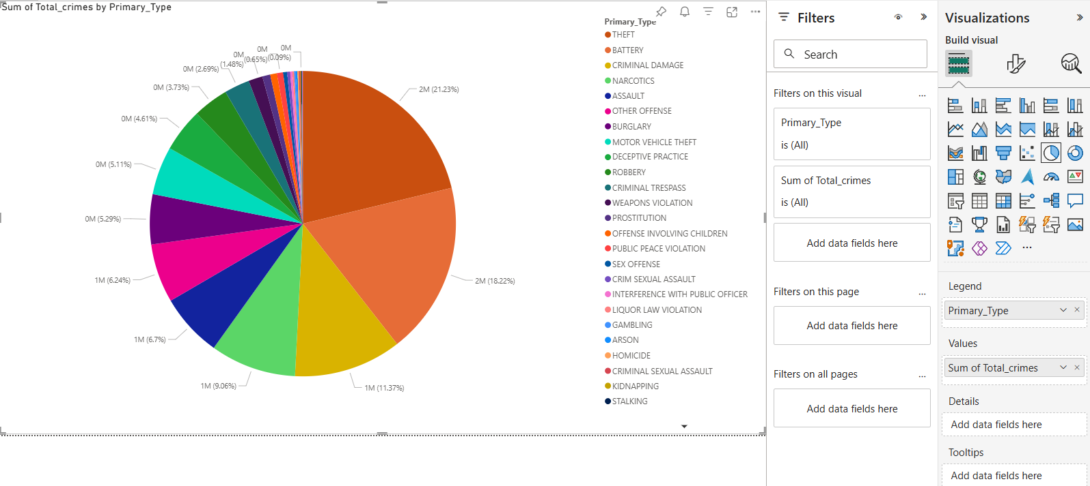
Figure 5- Crime Distribution by Type (2001-2025)
The line chart illustrates the frequency of each of the top 10 crime types in Chicago from 2001 to 2025 (Figure 6). Overall crime in Chicago has historically trended downwards over the years. Theft, Battery, and criminal damage have remained the top three most frequent crime types for more than two decades. Narcotics cases started high, but have plummeted since the early 2000s. Low-volume offenses from 2001 (including assault, motor vehicle theft, burglary, and robbery) have remained relatively low compared to the other top 10 crime types. However, despite the overall downward trend of crime in Chicago, all of the top ten crime categories have seen a noticeable spike or increase in the 2020s.
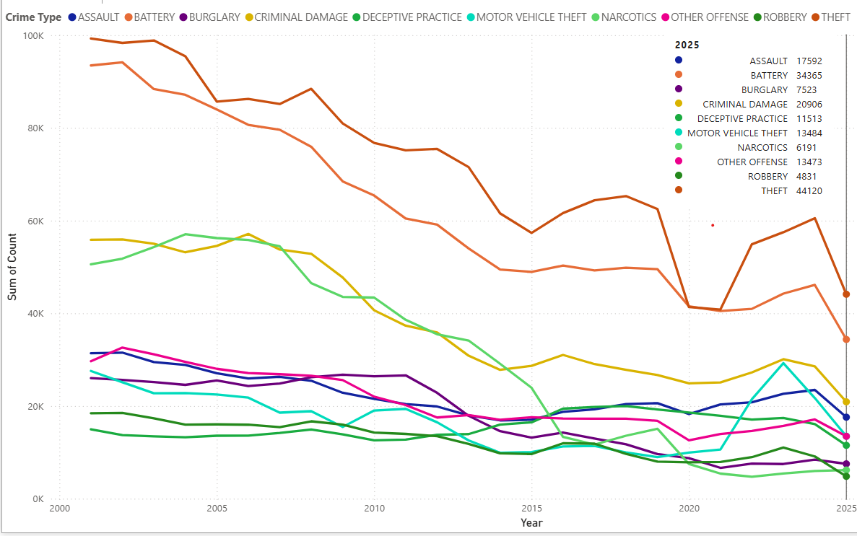
Figure 6- Trends of Top 10 Chicago Crime Types (2001-2025)
To analyze temporal patterns, this line chart tracks crime patterns across a 24-hour cycle (Figure 7). The data identifies a clear ‘safe window’ in the early morning, with the lowest activity recorded between 4:00 AM and 5:00 AM. As the day progresses, a distinct morning peak appears around 9:00 AM, likely coinciding with the start of the typical workday and increased commuter movement.
The most significant finding is the sustained surge in crime during the afternoon and early evening hours. Activity levels remain high throughout the workday, peaking in the late afternoon. This suggests that crime in Chicago is highly correlated with periods of high public activity and transit.
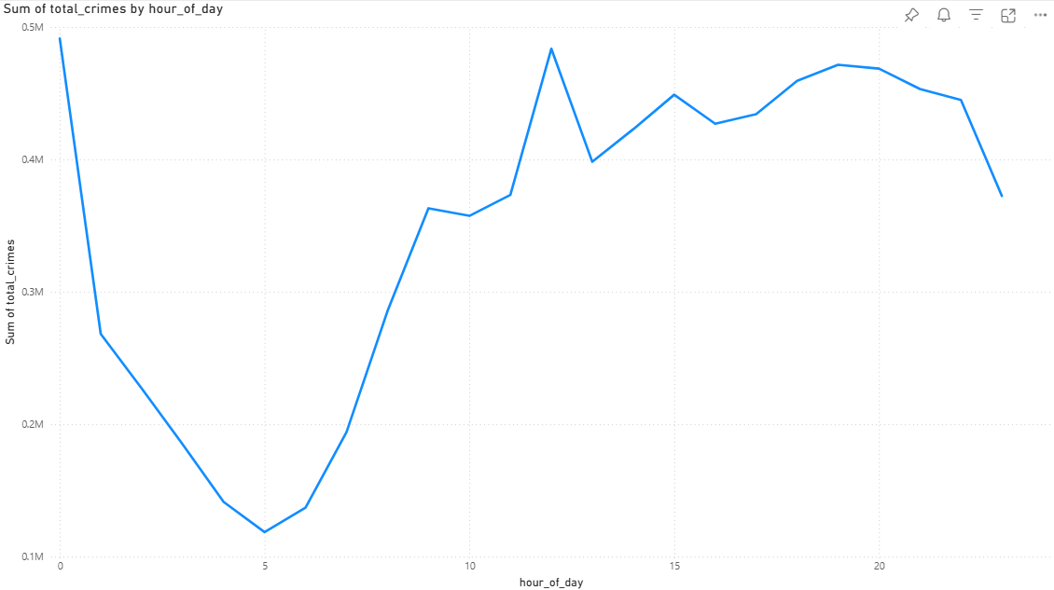
Figure 7- 24-Hour Crime Pattern (2001-2025)
This line chart breaks down the Total Crime Count by Day of Week (Figure 8) to identify recurring weekly trends. Friday consistently experiences the highest volume of crime, marking the peak of the week and the beginning of the weekend. Following this surge, the activity notably drops on Saturday and reaches its lowest point on Sunday, which is the safest day of the week.
During the standard work week (Monday through Thursday), crime levels remain relatively consistent and high (but not compared to their peak). This pattern suggests that high activity levels (e.g., crowds, commuting, and social activity) that often lead to crime are most concentrated on Fridays, rather than at the beginning of the week.
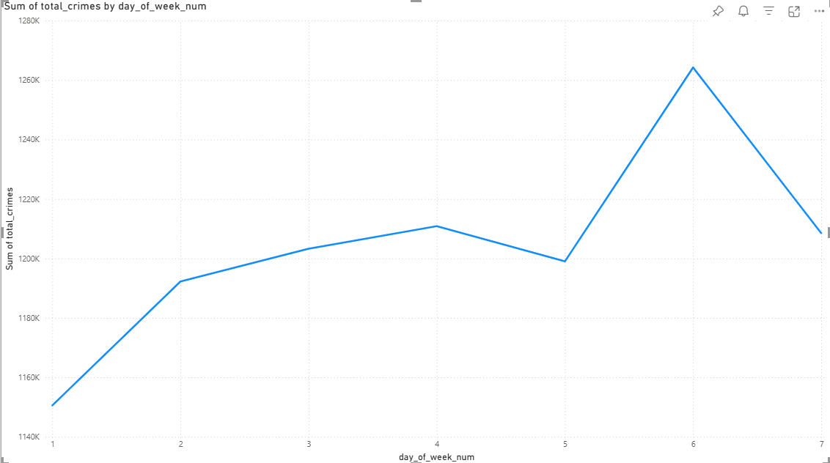
Figure 8- Total Crime Count by Day of Week (2001-2025)
7. Conclusion
In this project, Hadoop and Hive were utilized to process Chicago crime data from 2001 to 2024, revealing distinct temporal patterns, such as a “safe window” from 4:00 to 5:00 AM and significant spikes on Friday afternoons. This analysis demonstrates that crime follows predictable cycles rather than random occurrences, offering law enforcement a data-driven foundation to optimize patrol schedules and resource allocation during high-risk periods. It also facilitated a spatial understanding of crime intensity, which is crucial for effective resource allocation. Especially since it showcased all 22 police districts, with specific districts displaying a high, moderate, or low concentration of criminal activity. Additionally, it identified a resurgence in major offenses in the 2020s, despite a historical downtrend.
The relevance of this work could extend beyond Chicago. The city was specifically selected for this study due to the scale and detailed nature of the data. Given that Chicago and Los Angeles are both large metropolitan cities, this project could serve as a framework that the LAPD can adapt to identify similar crime patterns. The established framework and focus on temporal and geographical (district) analysis provide a scalable, data-driven blueprint that the LAPD can directly adapt to optimize resource allocation and proactively address public safety challenges in its own community. Ultimately, this project demonstrates how Hadoop and Hive can be leveraged to efficiently process, analyze, and visualize large datasets, yielding a real-world impact.

References
‌[1] “Crimes - 2001 to Present | City of Chicago | Data Portal,” data.cityofchicago.org, Sep. 30, 2011. https://data.cityofchicago.org/Public-Safety/Crimes-2001-to-Present/ijzp-q8t2/about_data
[2] M. Feng et al., “Big Data Analytics and Mining for Effective Visualization and Trends Forecasting of Crime Data,” IEEE Access, vol. 7, no. 1, pp. 106111–106123, 2019, doi: https://doi.org/10.1109/access.2019.2930410.
‌[3] T. Chen, K. Bowers, and T. Cheng, “Applying Dynamic Human Activity to Disentangle Property Crime Patterns in London during the Pandemic: An Empirical Analysis Using Geo-Tagged Big Data,” ISPRS International Journal of Geo-Information, vol. 12, no. 12, p. 488, Dec. 2023, doi: https://doi.org/10.3390/ijgi12120488.
‌[4] E. Mahimkar, “Predicting Crime Locations Using Big Data Analytics and Map-Reduce Techniques,” 2021. Available: https://tijer.org/tijer/papers/TIJER2104002.pdf
[5] ksalaz63, “GitHub - ksalaz63/ChicagoCrime2001-2025: CIS4560 (G5)- Term Project,” GitHub, 2025. https://github.com/ksalaz63/ChicagoCrime2001-2025

GitHub Link: https://github.com/ksalaz63/ChicagoCrime2001-2025

